IMO 2017 UK Student Report
Harvey Yau
July 9th to 24th, 2017

Introduction
This is a student’s report on the 2017 International Mathematical Olympiad in Rio de Janeiro, Brazil and the UK team’s activities. This is the tenth such IMO student report, and also the tenth anniversary of the first IMO student report written in 2007. To read the other reports, go to www.imo-register.org.uk/reports.html where leaders’, deputy leaders’ and students’ reports on competitions the UK has attended can be found.
First of all, our team scores were as follows:

Contestant Code | Name | Q1 | Q2 | Q3 | Q4 | Q5 | Q6 | Total | Medal
UNK1 | Joe Benton | 7 | 7 | 5 | 7 | 1 | 2 | 29 | Gold Medal
UNK2 | Rosie Cates | 7 | 1 | 0 | 7 | 0 | 3 | 18 | Bronze Medal
UNK3 | Jacob Coxon | 7 | 3 | 0 | 7 | 0 | 0 | 17 | Bronze Medal
UNK4 | Neel Nanda | 7 | 4 | 0 | 7 | 0 | 7 | 25 | Gold Medal
UNK5 | Alexander Song | 7 | 1 | 0 | 7 | 0 | 0 | 15 | Hon. Mention
UNK6 | Harvey Yau | 7 | 1 | 0 | 7 | 7 | 4 | 26 | Gold Medal
 | Total | 42 | 17 | 5 | 42 | 8 | 16 | 130 | 9th (out of 111)
 | Max | 7 | 7 | 5 | 7 | 7 | 7 | 40 | Gold Medal
 | Min | 7 | 1 | 0 | 7 | 0 | 0 | 15 | Hon. Mention

This year we came 9th, joint with Taiwan. This puts us top in Europe, above other countries such as Russia, Georgia and Greece. This is also the second time in a row that the UK has come in the top 10 of all countries.
Max, which is calculated by taking the highest score of each question, has a remarkable score of 40. This is easily enough for a gold medal in the competition, making this the 28th year that Max has gotten gold. This score of 40 is also the highest Max has gotten since 2005. Moreover, not only has Max beaten every other contestant in the whole competition, UK-Max has actually beaten the Max of every other country! So in a sense, the UK has performed the best in the whole competition.
Min, on the other hand, got a respectable score of 15, just shy of a medal, and a double honourable mention. This vastly outperforms last year’s Min performance of 9 marks and no honourable mention.
This is the fourth (and final) year that UNK1 has been Joe and UNK6 has been me. It is also the second year in a row that Joe has done the best on Day 1 and I have done the best on Day 2. Unfortunately Joe, as well as Neel, Jacob and Rosie will be leaving us. Alex and I will still be eligible for next year’s IMO in Cluj, Romania and Alex is eligible for a third year at a home IMO in the UK.

What follows next is an account in diary form of what I and the rest of the UK team did on the two weeks we spent in Brazil. This report was written well after the competition had ended, so inaccuracies may be present.

The Pre-IMO Camp

Sunday 9th July
Our flight to Rio de Janeiro is from Heathrow Airport Terminal 5. I arrive at the terminal with Australian deputy leader Andrew, who was also staying in London. We are flying with Dominic and Jill. Our first task is to receive our uniforms. This includes a shirt in a tasteful pink shade, an OxAM sponsored sleeveless jumper, a blazer, floral tie, and a comfortable zip hoodie, all stored in a UKMT-branded shoulder bag. Fitting them all in is easier for those of us who have large suitcases, but others who only have small cases have some trouble with this. Dominic also shows us two other shirts that came in the order: what was meant to be 2 4XL shirts was interpreted as a size 4 shirt and a size 2XL shirt. The scale of the size difference is comical enough for a photo.
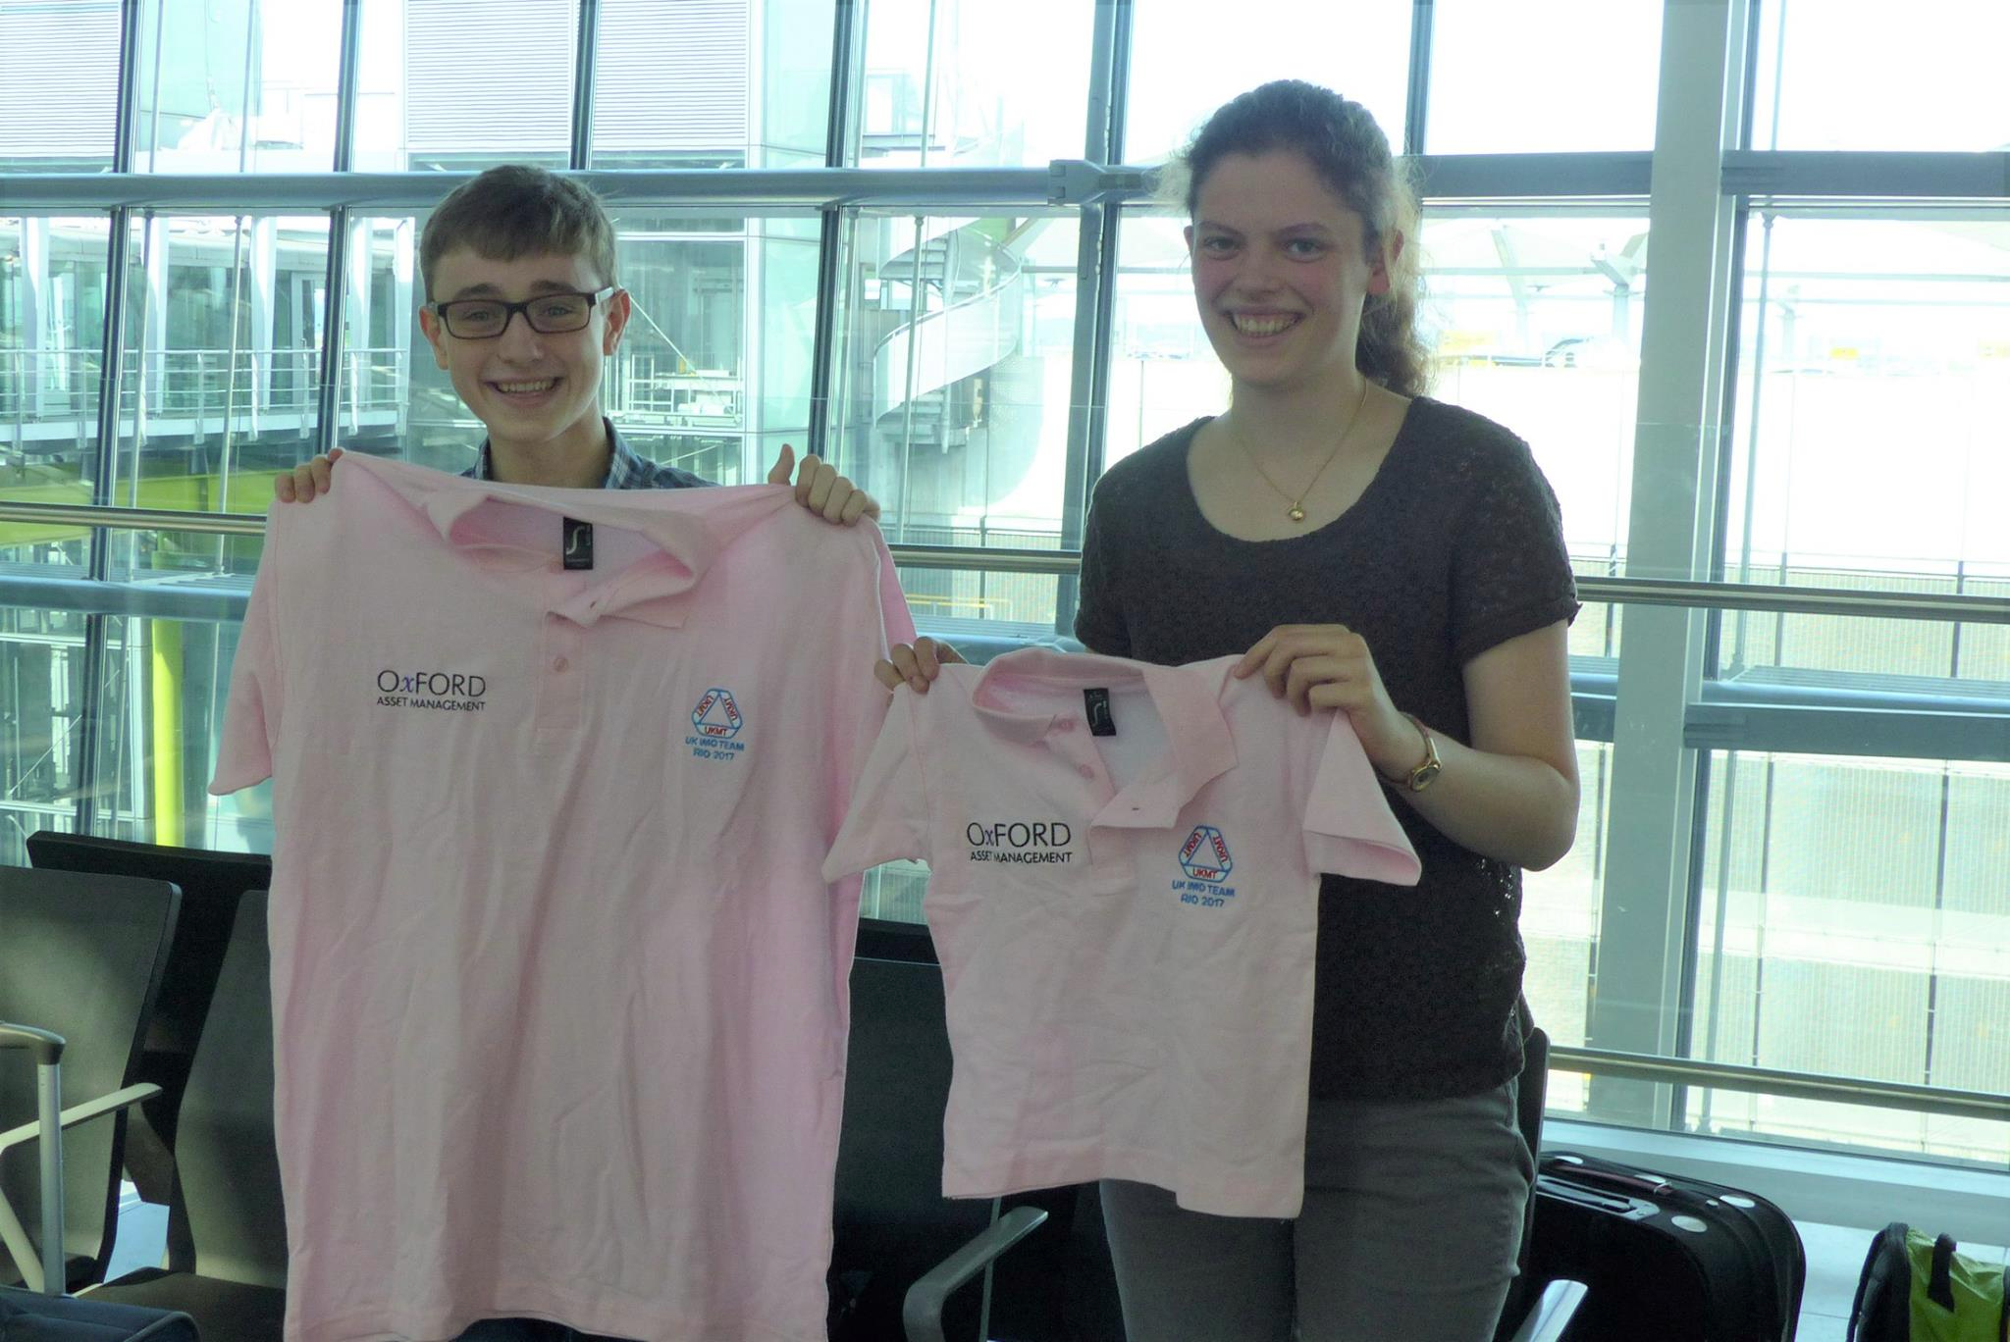
After making it through security, we have breakfast at one of the many restaurants in Heathrow airport. To keep our minds occupied, Joe introduces us to a problem he came up with involving princesses and frogs. We have some discussion of this, such as solving the easy case of n=1.
The flight was long but not short on entertainment. The British Airways computer system provided a variety of movies to watch, such as the Lego Batman Movie, and I also had my own devices. Free earphones were also provided. I had one extra pair for some reason, but it came in handy when the first pair I used were severed by an air stewardess pushing a trolley past. The food on the flight was also acceptable enough for me to eat and stop myself from starving.
Our plane lands at 8 pm local time. It is midwinter in Rio de Janeiro so the sun has already set. This does not mean it is cold, however. Rather, the nighttime merely means that the weather is a pleasant 20 degrees Celsius outside. After a long walk to passport control and customs we find that the coach to where we are staying is, surprisingly, already there and waiting for us to go.
The journey to the hotel we are staying in for the next week, called Albergo del Leone, takes something close to an hour. The temperature outside of Rio is noticeably colder, which is more suited to our experiences of winter, but still fine for wearing just a single layer. We are welcomed by the staff, who have generously provided us with a late evening meal featuring specialities such as local cheeses.
Our rooms are also assigned to us at this point. I share with Alex and Neel shares with Jacob, while Joe and Rosie get rooms to themselves. After a long journey, we are all tired and ready to go to sleep, after having a shower.

Monday 10th July
I wake up to what feels like a proper UK winter night, especially since our blankets are thin. This is because of the air conditioning in our room being turned up to full power and not because of the local climate during this time of year. This day is set aside for us to get over our jet lag, and our training begins tomorrow. Unfortunately, the presence of a loud rooster in the nearby area means that some of us are disturbed from our sleep as early as 4 am.
I wake up fairly early and head down to breakfast. They are serving a buffet of the same sorts of foods as we saw yesterday. Afterwards the four of us who are up (Neel, Joe, Jacob and me) decide to explore the hotel to see what there is around. We also meet the Australians, who arrived earlier than us yesterday but were already asleep when we arrived. With the Australian team are Angelo, their team leader, Andrew who travelled with us, and Nathan, the Australians’ Observer C and the one looking after them. The Australian team this year consists of entirely new faces, since everybody last year was in their final year. This also means that Alex, who is the youngest person on our team, is actually older than everybody on the Australian team. We manage to entice them into doing some maths by trying some ourselves and letting curiosity get the better of them. Afterwards we also try out some of the games they have brought with them, such as the card game Set. This is a game that used to be popular with the UK some years ago, but had fallen out of popularity and most of us had never played it before. Because of this we are demolished easily by the Australians, and never play it again.
Another game that the Australians are fond of is Contact, a word game. The main dynamic of this is to come up with clues that some people can guess the answer to but others cannot. Lunchtime ends up being filled by the sounds of clues being shouted out and cries of “Contact!” coming from the Australians’ table.
In the afternoon the plan is to go on a walk through the forest, called the Emperor’s Walk. Historically, the Emperor of Brazil used to live in Petropolis, a city nearby, and would take this path, hence the name. Most of the path is uphill and shaded by trees, which makes the viewpoints all the more notable.
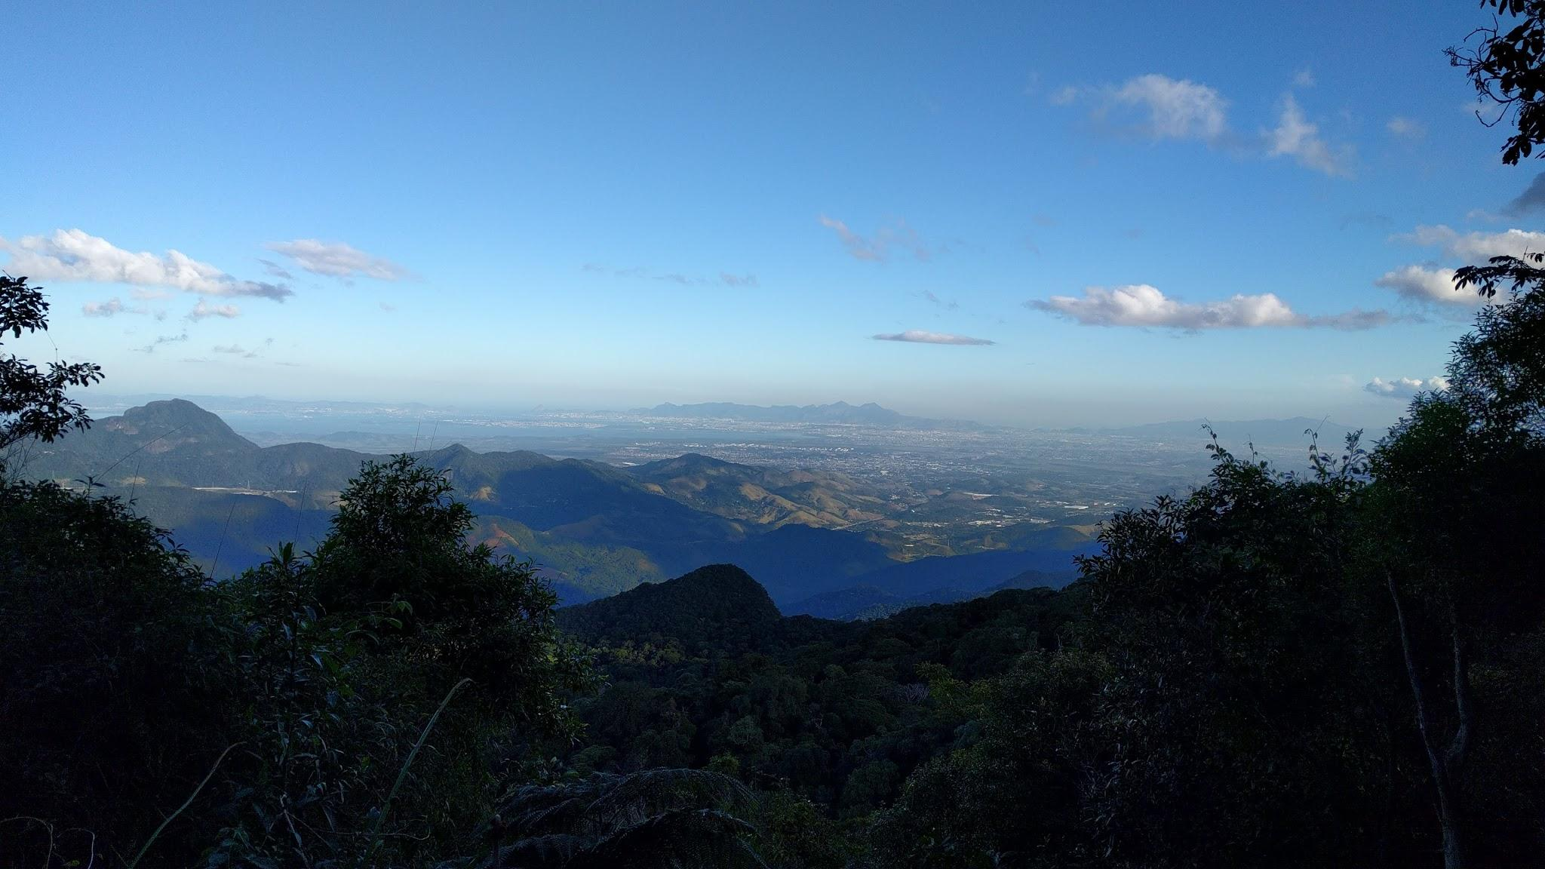
About 3 kilometres in, Dominic asks Marcos whether the path actually ends. “Yes” is the answer. Dominic figures we might as well continue onwards, to which Marcos says “It’s thirty kilometers.” Dominic then changes his mind and decides to turn back, although Marcos is still fine with continuing on to the end before heading back.
Back at the hotel, we discover Brazilian TV. After a quick leaf through the channels we settle on a Portuguese dub of the movie Gladiator, which is one of Jacob’s favourite movies. We never see the end though, because for dinner we are having a barbecue. It’s cold outside, but this doesn’t reduce the amount of fun we have. Or the amount of meat.

Tuesday 11th July
Today is the first of five training papers in this pre-IMO camp, known as F1, F2, and so on up to F5. To clarify, in this week before the IMO we do five more IMO-style papers, one every morning, each with three questions and four and a half hours. In the afternoon Dominic, Angelo (the Australian leader) and Andrew (the Australian deputy) will mark our scripts while we have free time to do what we like. In the evening they go over the questions and our scripts with us. There are also some differences in some of the papers’ formats, which will be explained later.
Our training tests are held at 8:30 am local time. This is 12:30 pm in British Summer Time, 8:30 pm in Australian Western Standard Time, 10:30 pm in Australian Eastern Standard Time, and 9:00 am in International Mathematical Olympiad Exam Time, which is what Angelo sets the exam room clock to. This is to help us familiarise ourselves with how the timing in the real competition will work, though as it turns out this is confusing and useless.
The free time we have in the afternoon is first spent doing more maths. Of course, our brains can only cope with so much maths in one day, so we decide to do something else. The Australians suggest we play a party game called Mafia, which used to be quite popular at other UK training camps, so we all know how to play it. Neel has actually brought a pack of cards and counters for a similar game called One Night Werewolf, so we decide to introduce the Australians to this instead. We play four rounds together. They seem to enjoy it a lot, though this is actually the only time we end up playing it.
Traditionally, one of the training papers in this camp is set by the teams for each other. It used to be the second-last paper, but this year Dominic has decided to move it to the third paper. Because of this, we have already begun to choose which questions will be on it this year. Our aim is to make sure we get lots of difficult-to-parse scripts to mark in order for us to gain the most out of this experience. However we also need to strike a balance between this and not making it too difficult so we get some progress to read on the later questions too.
We also do some more investigation of what rooms there are around the hotel, and find a kids’ play area with a table football table. I play a short game with Joe against Alex and Jacob, then we also play with the toys in the kids’ play area. This also somehow devolves into a re-enactment of the well-known philosophical question known as the trolley problem.
We go out for dinner tonight, at an Italian restaurant. Here we hear some more of the Australians’ enthusiasm for the game Contact - they play before, during and after the meal.
The UK team gather in mine and Alex’s room. We discover what is our favourite channel: FOX, which only shows back-to-back episodes of the Simpsons in Portuguese. The random humour of older episodes of the Simpsons works especially well when you don’t understand what they are saying.

Wednesday 12th July
The second training paper is today. The third question on today’s paper is very difficult and nobody has solved it, or even knows what the answer is. So in the afternoon Joe spends some more time and effort attempting it, and with some hints from Dominic, arrives at the correct answer. After this some of us head over to the kids’ room again, and become very enthusiastic about playing with the range of dolls and action figurines they have. This might be because of the high amount of concentration we use in the morning, or the boredom of not having anything to do in the afternoon.
Our interests shift towards Matthew Cheah of the Australian team, who is skilled at card tricks and throwing cards long distances. He shows us his technique for card throwing, and the whole UK team ends up joining in with getting cards to fly as far as possible.
We have dinner in another restaurant again, this time at a place that serves Japanese cuisine such as sushi. This isn’t particularly filling, so I end up ordering a lot more with Joe and Alex, and finish off our meal with a large bowl of noodles.

Thursday 13th July
Today is the third training paper, which is the one set by the students. We have set the Australians some fairly standard questions from recent competitions and shortlists, but they have set us some One Night Werewolf themed questions, including one of their own invention. I decide to respond to this by writing up a lengthy narrative-filled script to Question 1, which was set as a puzzle about people of the village of London.
This time we have lots to do in the afternoon. Joe and Rosie take question 1 to mark, I take question 2 to mark with Alex, and Neel and Jacob mark question 3. This is quite a fruitful experience as we have to trawl through many pages of rough, up to 16 in one person’s case. We also see in written form some people’s frustration and despair at not making progress in question 2. It appears as though the paper we set may have been a little on the difficult side, since nobody solved question 3, but despite this there was enough material produced to mean that Neel and Jacob were the last to finish their marking.
After the marking comes the coordination, which is where we discuss and justify the scores we gave them for their scripts. This could be said to be even more important than the marking. The Australians finish their marking earlier so they go before us.
The coordination for question 1 goes smoothly, with the final scores of 777717 being settled quickly. Next is question 3, where four more partial marks are given. We have some disagreement in how much certain bits of partial progress are worth in question 2, so we end up giving 1 more partial mark to everybody who did not solve question 2.
This time at the restaurant Dominic tries to get us to mingle with the Australians by switching up the seating arrangements. Not much mingling happens though, only Matthew ends up sitting amongst the Brits. He shows us a lot of his magic tricks, which are quite impressive when they succeed.

Friday 14th July
Angelo has to go to the leaders’ hotel in Rio for leader duties, so he is no longer here. Because of this, the exam room clock is also set back to standard local time.
Yesterday, while we were doing a training paper, Dominic had a go at walking up the nearest mountain. He did go the wrong way and get slightly lost, but after a while he found the right way up. So today he suggests we should also trying walking up the mountain with him. We go along with this.
After a short taxi ride we reach the base of the mountain, and find the path. It is more of a hike, the path is sand and quite steep, which is not a good combination. Neel almost disappears off the face of the mountain at one point. Moreover, somehow Dominic manages to completely miss the right path again and get us lost. It wasn’t all bad though, since we got some good photos and saw a toucan as well.
The next challenge is to get a taxi back to the hotel. Dominic tries to call Jill to tell her to phone for a taxi. We end up having to wait for almost an hour for a taxi to show up.
After dinner we play pool since there is a pool table in this hotel. Matthew introduces us to a different game called Offensive Pool, where the aim is to pot the other players’ balls before they pot yours. Joe is much better than everyone else, so Neel tries to get the others to gang up on him.

Saturday 15th July
Today is the final training paper, which is also the Ashes paper. For those of you who don’t know, every year in the pre-IMO camp the UK team and the Australian team both do a single IMO-style paper at the end of the camp, and the team with the highest total score wins the Ashes competition and trophy. The trophy is an urn holding the ashes of the burnt scripts of the first ever Ashes competition, and since then the Ashes have been exchanged between UK and Australian hands a number of times. This year we expect to win, since we have a lot of experience and a very strong team whereas the Australian team consists of entirely new people.
The Ashes take place in the morning just like every other exam paper, the only difference is that we are seated separated by team. Afterwards we go to Petropolis, a nearby city, with Jill and Nathan while Dominic and Andrew mark all of our scripts. We go by coach, and after a very bumpy journey we reach the Imperial Museum. This museum is what used to be the Imperial Palace where the Emperor and royal family of Brazil lived. It is quite popular and the queue to enter is massive.
We end up spending a whole 45 minutes in the queue before we reach the entrance. It is only then that we find out that we have to buy our tickets somewhere else, and we are worried for a moment that we might have to stand through another 45 minutes of waiting. Luckily Jill and Nathan go to buy the tickets while the rest of us hang around just outside the doors awkwardly and in the way of people, and after a lot less time we are in.
To protect the palace floors we are given large slippers to wear over our shoes when we enter. This, combined with the surface of the floors, makes sliding around the easiest and most efficient way to move around the museum. As a result, most of our interest is not on the various exhibits like the throne, beds and decorations but rather how far we can propel ourselves across the corridor by pushing each other. It is like a much more fun version of the mountain climb in terms of slipperiness. We are so engrossed in this that at one point Jacob, Rosie and me are separated from the rest of the group, but since the museum is cordoned into a single path it is easy to find the others again.
Our tour of the palace finishes at 4:40 pm, which meant that we spent more time queueing than in the museum. However this still leaves us with a lot of time left - the restaurant we are going to for dinner was booked for 6:30, giving us almost two hours to spend. So we also end up going to the cathedral in Petropolis and admiring the stained-glass windows for a while too.
Dominic and Andrew meet us at the restaurant and announce the results of the Ashes by passing the scoresheets around the table. We won, and with a huge margin of twenty points. This does not cause any animosity between the teams, and the Australians play the game “Spyfall” with some of the UK team.
It is late when we get back to the hotel, but we decide to celebrate our victory by watching one of the DVDs that Dominic brought. We decide on Mean Girls unanimously.

The IMO

Sunday 16th July
Today we leave Itaipava and go to Rio de Janeiro proper. The training exams have ended, so most of us get a lie in. Some of the UK team (Joe, Jacob and Rosie) go up the mountain we failed to reach the top of last time with Dominic, while the rest of us stay with the Australians and get on a coach at 9:30 to Petropolis. Jill makes sure we haven’t left anything behind in our rooms or forgotten anything else.
This time, we are walking through a National Park-like place in the city with lots of trees and protected wildlife. We are led by our wonderful guide Marcos, who tells us lots about the different species of trees and which ones are special or endangered. The walk is a lot easier than the mountain one, but it is still quite steep at points.
Lunch is at a restaurant called Lago Sul, which is next to a lake and a noisy event. This restaurant has a special way to serve their food which we find out later is actually quite common in Brazil. First, you sit at the table with a plate in front of you. Next, waiters come round holding massive sword-like skewers of meat. If you decide you want some of what they hold, the waiters then carve off a large slice of the meat onto your plate. While eating this, the next waiter will come to your table. This cycle continues until you are completely full, at which point they bring out the variety of desserts they have. Whether you have dessert or not, you leave the restaurant feeling extremely full, not wanting to eat for the next ten hours, and possibly slightly sick if you went too far. I would not recommend this to a vegetarian.
Dominic, Rosie, Jacob and Joe join us at the table while we are halfway through the feast, i.e. feeling quite full already. They have their fill too.
After the meal we stumble our way to the coach, which is waiting for us to take us to our next destination, the Windsor Oceanico Hotel in Rio de Janeiro. Upon arrival two hours later we step out of the coach to admire the height of the hotel and the proximity to the beach.
Next we have to wait for the organisers to sort out our rooms, passports et cetera. While we wait we meet our guide for the week, Jessica. She gives us our lanyards and some green bracelets that we need to always wear so that people can identify us as contestants.
Tired after the long journey, we are glad to receive our room key cards. I head up to the room I am in with Joe, but when we open the door we find that the only bed in this room is one double bed. So we end up having to wait for a while longer before our room is sorted out and we are relocated to a room with three single beds.
The dining hall in this hotel requires lunch and dinner vouchers to get into. Jill keeps all of the vouchers for us and distributes them when we need them. The food in the dining hall is a buffet, and even better, there are lots of greens and vegetables. After the meat-heavy lunch we had, this is a pleasant change.
Next we explore the recreation room. There are lots of board games, some ping-pong tables, two TVs with Netflix set up on them, a row of computers with internet access, and even two Xbox consoles where some people are playing a football game.
Jacob also spots a door with a sheet of paper stuck on it saying “Karaoke”. He opens it to take a look inside, but after the cacophony of noise and almost desperate beckoning that comes from within he quickly closes the door and pretends we never saw anything.
Anyway, next we head up to the roof to admire the view. It is night time already, but we can still see the lights that line the beach stretching out to the horizon. Closer to us are the other hotels and buildings.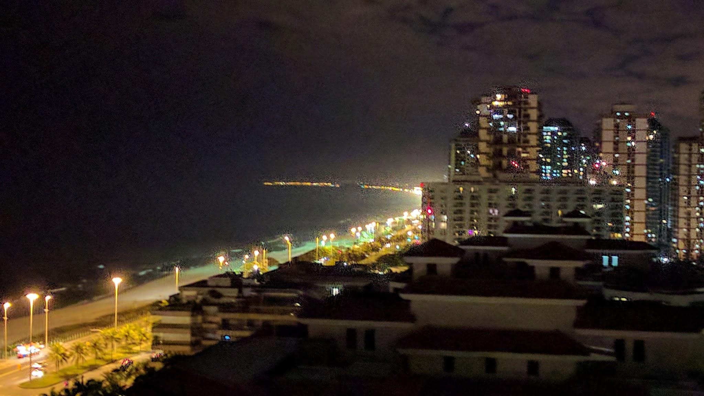

Monday 17th July
The opening ceremony is today, but it is in the afternoon so we have the morning free. We spend this by going down to have breakfast and watching TV in our rooms. Soon we get bored of this so we go down to the recreation room and watch people play on the Xbox instead.
The opening ceremony is scheduled to begin at 1:30, but it does not actually start until later. During the waiting period I look at some Belgian maths problems with Rosie and Joe.
The ceremony begins with a variety of speeches from different people from the IMO and their sponsors. Geoff also gets a speech, and even tries speaking in Portuguese for some of it. This gathers a lot of applause, though most of us don’t know how good his Portuguese actually was. Geoff is also in charge of reading the IMO oath with two other IMO contestants.
The most exciting part of the opening ceremony then happens. Each country’s team goes up to the stage to display their flag and have their photo taken. This whole procession, which takes the best part of an hour, is accompanied by a string orchestra playing a variety of tunes which we soon figure out to be pop music. It keeps us entertained throughout the team parade even though the clapping dies down.
As the last team to go up, Brazil, walk off, somebody in a costume of a blue bird much like the one from the movie Rio walks onto the stage and starts dancing. We are not sure what to make of this but clap and cheer anyway. Next up is a marching band which also plays a few popular tunes, though I don’t recognise all of them. Nevertheless the whole of the second half was very well executed and entertaining.
To get some fresh air we have a walk outside along the promenade with Jessica and Dominic. We got quite far, and on the way back we stop off at a supermarket to buy some snacks for the exam.
Jessica recommends a cafe where we can have some juice, so we stop there. We order some juices, all of which are nice and refreshing, and a Brazilian snack called açaí. It is like a slushie but made from sweet berries, and served with granola. It goes down well. Later on, Jill also meets us at this cafe.
When we get back to the hotel I discover that my key card has stopped working. Jacob’s has too. We end up having to go to reception to sort this out.

Tuesday 18th July
To enter the exam hall we have to stand in a really long line that takes forever to move along. It turns out that they are having security screenings to make extra sure we aren’t bringing in any prohibited items such as calculators, watches or books. As an extra precaution to stop us from knowing the exact time of day, instead of using clocks they have provided us with a giant timer projected on screens at the front that show the time elapsed.
After the exam finishes we have to wait for our scripts to be collected. However first the invigilators wait for every single person to completely finish writing their names and contestant codes on every sheet of paper they have used and sort them all into the right folders. Because of this we are all stuck waiting for one contestant who has not done any of this during the exam time and is only starting to do this now. Only after that one person has finished do the invigilators begin collecting our scripts, which also takes a long time. Overall we are stuck in there for much longer than it should have been, and the fact that we have no watches to check exactly how long that was makes the wait even worse.
We meet up outside the exam hall with Jessica, Jill and Dominic to discuss how well we did. Most of us only managed to complete question 1, except for Joe who despite feeling unwell managed to do all three questions, although he did not have enough time to write up his question 3 solution. We are especially frustrated with question 2, which seemed much too difficult for its place on the question paper.
Lunchtime is in the dining hall, and we notice that most of the other teams are in equally sour moods. Even the weather is grim, with dark clouds, heavy rain and strong winds. To cheer us up, Jessica suggests we go to a Lego sculpture exhibition in a shopping mall nearby.
We take taxis to the shopping mall and enter the exhibition. There are a lot of Lego sculptures by the same artist, and he has also provided helpful commentary on his thoughts and feelings about each piece. There are also a fair number of sculptures of humans, and a lot of them we can relate to after this morning’s exam.
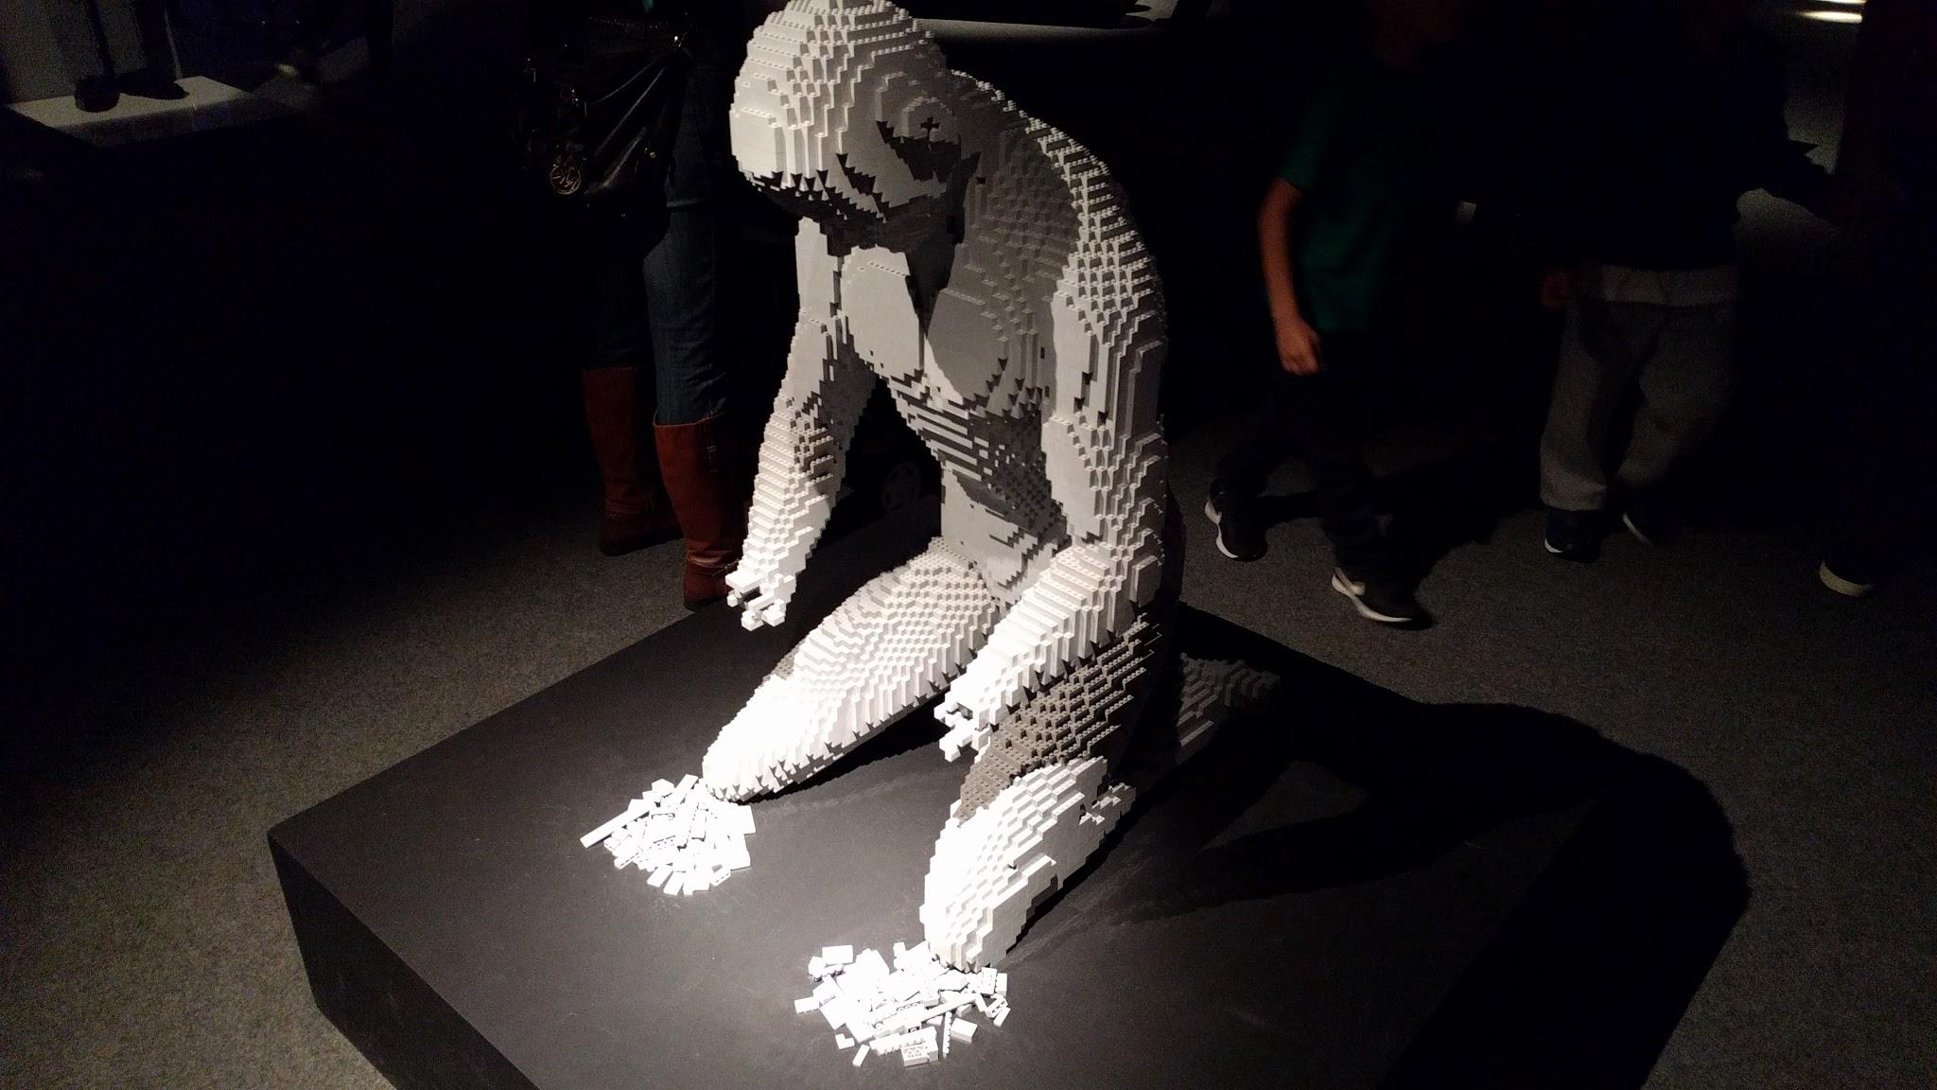
After we finish our walk through the exhibition we stay in the mall for a bit longer to have some ice-cream before heading back to the hotel. We have to sit through a long traffic jam because of the poor weather.
In the evening after dinner Neel and I decide to actually go and try out the karaoke. We have a lot of fun and sing a lot of songs. Alex joins us a bit later, but doesn’t sing as much.
Heading back up to my hotel room, I see Jacob. His keycard has stopped working again, but he has managed to pinpoint the cause to be keeping it in the same pocket as his phone. We get the card sorted out again for the last time before going back to our room.

Wednesday 19th July
On Wednesdays we wear pink. Most of the team turn up to breakfast in the pink shirts we were given at the beginning of our trip.
Again, we need to make our way through the multiple layers of security before we can enter the exam hall. This means that Jacob needs to go back to our room to pick up his lanyard.
The second paper goes much the same as the first, but the invigilators have improved from yesterday and are a lot quicker to collect our scripts after the exam. We end up being able to leave for lunch a lot earlier today. Again, we meet up to discuss how the paper went, and it was about as bad as yesterday. Most people only managed to solve question 4, but Neel did question 6 and I did 5 and 6 as well. I am not sure if I managed to solve question 4 though, because I only came up with the idea for how to do it in the last 5 minutes and finished writing it with only 30 seconds to spare.
The weather today is slightly better than yesterday, but it is still cloudy, windy and unfavourable. Nevertheless we still plan to go out this afternoon. This time Jessica suggests the fort at Copacabana.
Before we leave though we have to get from the dining hall to our rooms, and then from our rooms to the lobby. This is difficult for Alex and Jacob, who have left their lanyards behind - Jacob’s is in the dining hall while Alex’s is with the rest of his stuff safe in Jill’s room. There are now lots of security staff stationed at various points around the hotel and stopping people without lanyards. The security stops now mean that it is impossible for Alex and Jacob to actually get to the location where their lanyards are in order to pass through the security. So instead I go to retrieve their lanyards, but Dominic already has them and this results in a frustrating wild goose chase before they are reunited with their lanyards.
At Copacabana we enter the fort. We see some of the machinery and engines kept inside the fort. There are also some displays with more details about the history of the fort, but they have lots of text and are all in Portuguese so we don’t get much out of it. After walking around for a little while we leave and order some cakes and pastries at a nearby cafe.
It is getting dark by now, but we walk for a little bit on the beach at the Copacabana, which is very empty because of the time and the poor weather. Some of us decide to take advantage of the lack of people and write out the functional equation for question 2 in the sand. Dominic and Jacob also decide to go and wet their feet in the sea.
After waiting for a taxi to take us back to the hotel, we have dinner and I spend the evening in the recreation room. There is some Lego lying about in a box, which Rosie and I take to try to build a hunter. Then one of the Moroccans invite us to play a game of Cluedo (or Clue in other countries). The first game ends very quickly due to a lucky guess by me, and Jacob joins in for the second game. After I win this game by default due to everyone else losing, I decide to go and join Neel in the karaoke room again.

Thursday 20th July
The papers are finally all done and over with. We get to have a sleep in, but I end up waking at about 8 am anyway.
The security around the hotel has tightened even more, and now they are checking for the bracelets we were given at the start of the competition and are still supposed to be wearing. Most of us have already taken these off a long time ago and have lost them, so we end up wasting a lot of time trying to circumvent this.
There are two days after the exam days where the leaders and deputies go through the scripts we wrote. Then they meet up with the coordinators and together they argue to decide on what mark the script should get. While this happens the contestants have a lot of free time, so usually there are excursions arranged for the contestants on both of these days to keep us occupied. This time however only one excursion has been organised, and for only the morning instead of the full day it usually is. Countries in the first half of the alphabet are going today and countries in the second half (which includes us as the United Kingdom) are going tomorrow. Because of this there is nothing officially planned for us today.
Jessica helpfully takes us to see the Sugarloaf, which is a noticeably steep mountain in Rio de Janeiro. Dominic also joins us on this trip because he does not have to go to any coordinations until the afternoon. At the base of the Sugarloaf there is a cable car station that takes people to the top of a nearby hill, where you can stop and buy drinks or souvenirs before taking another cable car to the top of the Sugarloaf. There is also an easy walk to the top of the first hill. Dominic, Alex, Joe and Jacob take the walking option. I want to see the view from the cable car so I join Jessica, Jill, Neel and Rosie. We meet back up at the top of the first hill and take the second cable car trip together to the top.
When we arrive the peak is inconveniently covered by a cloud, meaning the only view we can see is a light grey colour background. Luckily the cloud does clear away quite soon, so we are able to take some better photos and admire the view.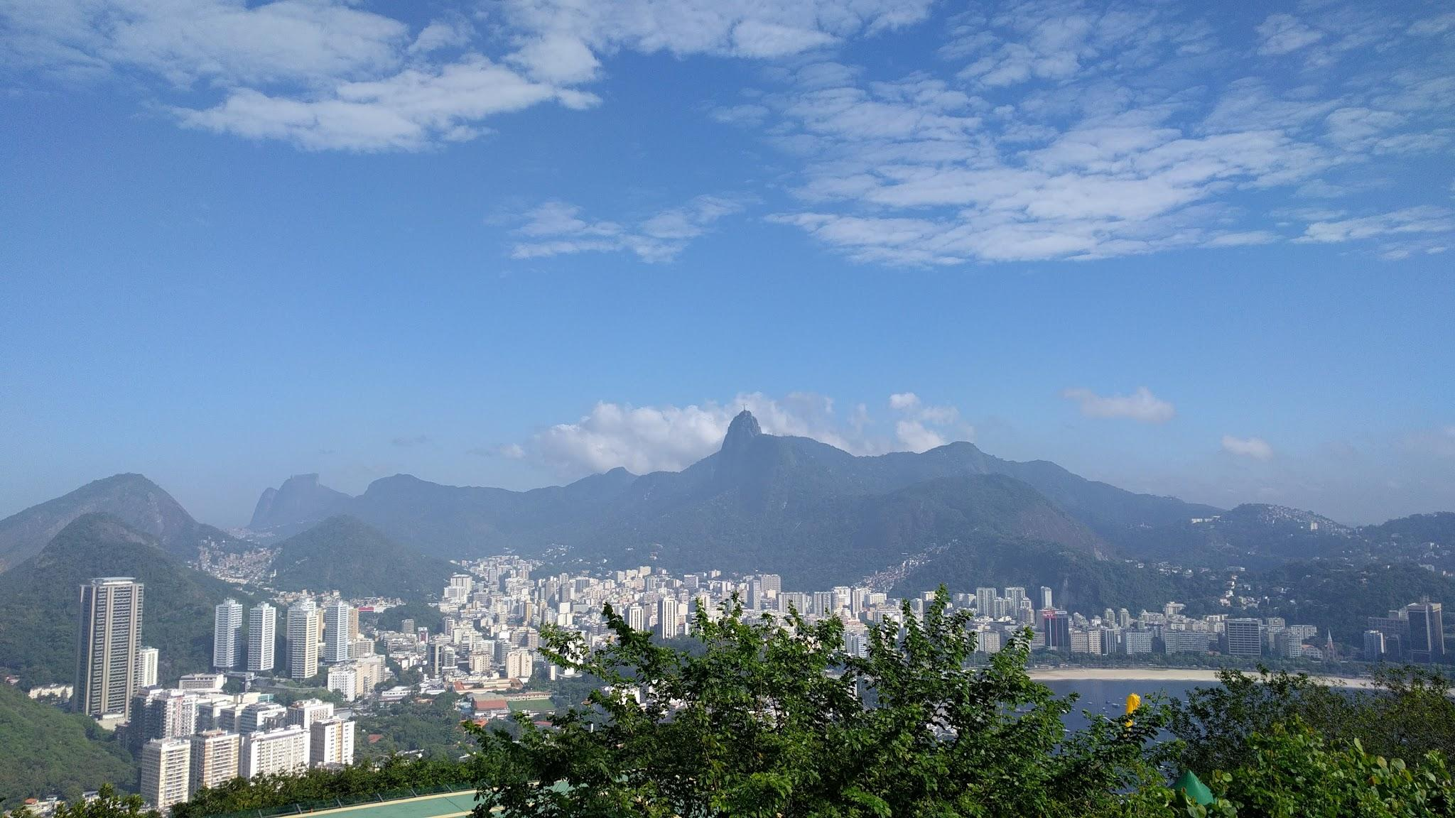
After some photo taking, we head back down one stop and take a break at a cafe there. They also serve açaí there, so we order several cups.
Back at the base of the mountain, we say goodbye to Dominic who has to go back to the leaders’ hotel to coordinate our question 3 and 5. We continue on to our next stop of sightseeing Rio: the famous statue of Christ the Redeemer. First we take a minibus to a stop halfway up the mountain that the statue is on. Next we buy tickets for another minibus that will take us right to the top. Then we scale a few more flights of stairs to reach the platform that Jesus stands on. Now we are really high up, and can see almost all of Rio. However it is very crowded, so it is difficult to take good pictures of us and Christ in the same frame.
We arrive back at the hotel about half past 3, and have a very late lunch. We are one of the last teams in the dining hall, and a security guard approaches us to tell us we have to go to the beach next the hotel to get photos taken. It is a very short distance, but there are still lots of security around to make sure we cross the roads safely.
At the beach there are too many teams to count. There are also too many teams to take one good photo of, so they have drones to fly above the crowd and film us trying to get in shot. We try to get our signpost, which has the UK flag on it, high up so it stands out by putting Joe on my shoulders, but it is too windy and the sign just gets blown back. Soon we get bored, but the security stops us from leaving early. Luckily, because we were one of the last teams to arrive, we are at the edge of the crowd and so we get back to the hotel first, ahead of all the other teams by a lot.
The security escorts us straight from the entrance of the hotel to the room where the opening ceremony was held, where another event called the “Round Table” was occurring. Actually, it was scheduled not to occur for another hour. After realising this the security lets us leave.
I return to my room with Joe, while Jacob and Alex go swimming. There are sumo wrestling highlights on TV, so I watch that. Neel and Rosie go to the Round Table, but Joe and I stay in our rooms for the rest of the afternoon.
Tonight we are going out for dinner to meet with Dominic, Geoff and our Observer A, Steve Mulligan, who organises the team maths challenges. The restaurant we go to specialises in steak, which is what most people order, though I get a burger instead. Each steak comes with a single whole chilli, possibly for decoration. However it soon becomes an object of discussion, and one remains on the table as dessert is served. Jacob even goes ahead and says that he will sing five karaoke songs if I eat the whole chilli. This is an offer too good to refuse, so I take him up on it and eat it. Alex, who was watching, is very impressed, though at that point the main thing I cared about was getting enough cold water for my mouth.
It is late when we get back to the hotel, but we still manage to get Jacob to sing one song before we give up and go exploring the hotel instead. By the time I get back to my room it is midnight.

Friday 21st July
Today our team get to go on the official excursion. It is in the morning, so we have to get up early enough to make the buses. However we end up being quite a lot later than the organised time of 8 am, so we end up on bus number 8, which is presumably the eighth bus to leave.
Our first stop is the lagoon. We saw it from high up from Christ the Redeemer yesterday, but today we get to go right up next to the edge of the lake and take some photos. There isn’t much to do here, so we only stay for about 15 minutes before leaving again to go to the next stop.
The bus drops us off near the Boulevard Olimpico. To actually get there we need to walk past a few buildings, which have been covered from top to bottom with stunning street art. It is very colourful and vibrant.
When we reach the main square, which is right next to the sea, we are told we can wander around for 20 minutes before meeting back up. There are a lot of people in the main square, and there is also the Museum of Tomorrow, a very futuristic-looking building. Unfortunately we don’t have enough time to see what’s inside, and we don’t have money for tickets either, so instead we just walk around the building and see what there is around.
Our next stop is the Maracana Stadium, the famous football stadium in Rio de Janeiro. This time we are given a lot more time to look inside at the changing rooms, football pitch, seats and some other parts of the stadium. There isn’t that much to look at though, so we end up sitting around for a while waiting to go back on the bus.
That was the last stop on our tour of Rio, and I am already quite tired so I sleep on the bus on the way back.
After having lunch at the hotel we go to see the IMO lecture, by Artur Avila, an IMO gold and Fields medallist. He talked for a long time about notable mathematicians who also went to the IMO and a little bit about what type of maths each of them did. It didn’t contain much mathematical content, but still went on for an hour and a half.
In the evening all the coordination has ended, and they are deciding on the medal boundaries. Most people stay up for the results to be released, and when they do, so many people check the IMO official website that it slows to a crawl. We find out how well our team did. Neel is very happy that he managed to get a gold medal. We celebrate together by singing more karaoke, as usual.

Saturday 22nd July
The closing ceremony is later in the afternoon so we still have a lot of free time. Dominic joins us again, and today we head out to the Boulevard Olimpico again. We planned to visit the Museum of Tomorrow, but Jessica couldn’t get the tickets online and the queue outside is much too long to for us to wait in, so we give up on that idea and decide to go for another walk around this area.
We have lunch here as well, we order pizzas and chips at a busy restaurant and take seats in the large area outside. There is a little trouble with the waiter having to remember all of our orders but the pizzas do eventually come. We stay there for quite a while before taking taxis back to the hotel again, and when we arrive there is not much time left until the closing ceremony.
After quickly getting changed head over to the closing ceremony room, which was also the room we had our exams in. The organisers need to check who we are and what score we got in the papers because we are being seated by our score. This makes the medals presentation faster and more efficient. Joe is in the front row, having come joint seventh in the whole competition. I am in the second row, and seated almost directly in front of Neel, who only got one less mark than me. Within each score bracket we are sorted by country order, so I am next to the Americans.
There are some more speeches and videos about the competition and its sponsors, and then the honourable mentions are listed on the two large projected screens on either side of the main stage. Next up are the bronze medallists, we cheer on our teammates and the Australians enthusiastically. The medal awarding itself is a bit hectic, with many more contestants than people presenting medals, and it seems like most people don’t know what they are doing. Also, as it turns out, as well as the medals we are being presented they are also giving out a plushie of a blue bird much like the one we saw dancing about in the opening ceremony to each medallist.
The gold medals are presented after the silver medals, and Joe, Neel and I are very happy to receive our medals. I decorate my blue bird doll with my medal when I get back to my seat.
A little later, the person in the blue bird costume goes up on stage and starts dancing again. It is also revealed that this blue bird is actually called Aramath, and is the official mascot of the IMO 2017. If they told us this a bit earlier we probably would have been less confused to see it dancing on stage during the opening ceremony, but the plushies are still quite nice.
After the handing over of the IMO flag to the Romania team and another clip about where the IMO will be held next year, the celebrations start. A conga line of the contestants mysteriously forms and almost everyone is dragged in. This means that the UK team is late to the closing banquet. There are a lot more teams than tables, so we have a lot of trouble finding somewhere to sit and eat the food provided. A group of samba dancers also enters the hall and begins dancing, and lots of people join in to that as well. I leave early because it’s very stuffy and noisy in there.
As a final sort of thing, we arrange to meet up on the roof at 9:30 pm. There, we talk about various things and the future, such as mentoring schemes.
I go back to our room and Joe joins me a bit later. We go to sleep, but Jacob has decided to try and stay up all night to try to combat jetlag on the flight back to the UK.

Sunday 23rd July
The team hasn’t taken an official photo together yet, so we change into our uniforms and head up to the roof to do so. It is very bright and sunny as well, so we struggle to keep our eyes open when the photos are taken, and this results in a lot of failed attempts of photos. Eventually Dominic gives up and resorts to getting a friend to edit the pictures together to create one where nobody is blinking.
After packing all our luggage we drop it off in Jill’s room, which has been booked for a late checkout. Then we head to the beach nearby. I sit on the towels that Jill has borrowed from the hotel for a while. Neel, Rosie and Joe go up to the shoreline and let the waves wash over their feet. I join in later as well, but the waves have quite an unpredictable strength and even with my trousers rolled up as high as they will go they still get wet.
We have lunch at a restaurant very close to where we were on the beach, this time we are joined by Geoff, Steve and Ursula, who will be the lecturer at the annual IMO Celebration lecture at the Science Museum in London. This restaurant is another all-you-can-eat meat place, but this time they also have a buffet of various sides, such as sliced tomato, salad, and sushi. Once again we all end up eating a lot more than would be normal for a lunch.
There is still a lot of time before our flight back, so we head back to the beach for another half an hour. It’s probably not the best idea to do any vigorous exercise after such a large meal, so instead we relax, enjoy the great weather and watch the waves lap up on the beach.
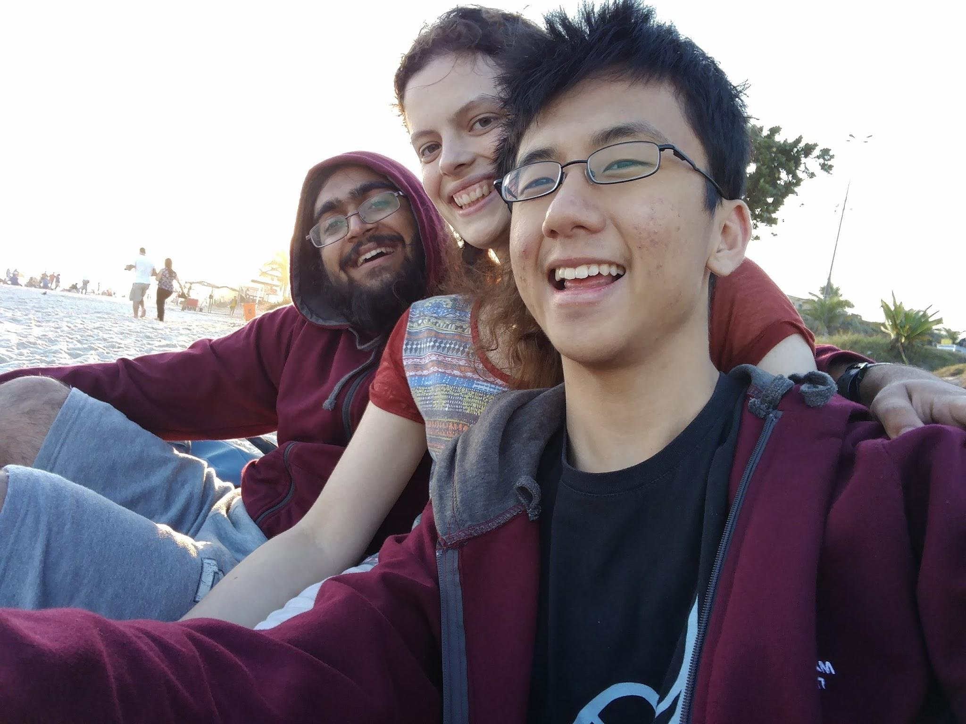
The bus for the airport is scheduled to leave at 5:45 pm, so we go back to the hotel about half an hour before that. This gives us enough time to have showers and change clothes to prepare for our long journey back home.
At the airport we have lots of time to spare. During the long time we spend waiting we see the Dutch, Norwegian and Hungarian teams all pass us by before it is our turn to board our flight, which is at 9:45 pm. To take advantage of the wait I show the rest of the team my slightly unorthodox solution to question 4.
The flight is overnight, and I sleep for most of it. Jacob somehow plans to stay up throughout the whole of it, even though he has already stayed up all of last night. He fails.

Monday 24th July
Going through Heathrow Airport is a painless experience, since all of us have microchipped e-passports, meaning we can breeze through passport control. After baggage collection we reach the arrivals waiting area and the UK proper. At this point Geoff presents us with our scripts as a memento to keep forever. Here the team breaks up and we go our separate ways, and here my account of the events we went through as a team over the past two weeks ends.

Acknowledgements
Countless people’s efforts have gone into making the IMO a success, and countless others have also gone into supporting the UK team. I cannot list them all here and I do not know where to begin, but here are some thanks anyway:
- Everybody in Brazil who helped make the IMO 2017 the successful event and competition that it was,
- The IMO Foundation and IMO Board, for also supporting the event,
- The UKMT and all the schools throughout the UK who support the UKMT, for creating such an extensive maths programme to help UK team candidates,
- Oxford Asset Management, for sponsoring the UKMT,
- Everybody who has been to any of the multiple training camps the UKMT holds throughout the school year, as staff or students, for keeping our interests in maths and helping us train and improve,
- The Australian team and delegation, for competing with and against us over these two weeks,
- Geoff, for being a wonderful leader of the UK team as well as his other roles in the IMO board, and his pivotal role in getting us 7s in coordination,
- Jill, for looking after us these past two weeks and making sure we were completely fine throughout our time spent in Brazil,
- Jessica, for being an amazing and helpful guide and always making sure we managed to get to wherever we needed to go, be it hotel or statue of Christ,
- Dominic, for helping to organise the camps throughout the year as well as the multiple excursions we went on in Brazil, also for looking after us during our time at the pre-IMO camp and the IMO competition, and also for gaining us the crucial marks we needed in coordination to achieve the stellar result we got,
- And finally the whole of the UK team, Joe, Rosie, Jacob, Neel and Alex, for making the whole of the two weeks I spent in Brazil such a wonderful time, and for the team result we got that was so successful.

